Inbound Marketing Workbook
Company: ___________________________

Workbook Instructions for Marketing Agencies

This workbook is designed to help you identify your prospect’s sales and marketing challenges as well as their revenue growth goals. Once you’ve identified those, this document will also help you co-create an inbound marketing proposal with your prospect.

By leveraging this workbook to conduct a thorough qualification, goal setting and planning process with your prospect, you should be able to produce a proposal that is appropriate for each prospect, given their skills, resources, budget and goals.

To master this consultative sales and inbound marketing planning process, you’ll also need to develop new processes, new service offerings, new skills, as well as knowledge of the inbound marketing methodology and HubSpot software. We highly recommend that you leverage inbound marketing to build your own business or the business of a current client, where you have the flexibility to learn as you go.

In order to gather much of the data needed to complete this workbook, you will need to start a HubSpot free trial for your prospect. We allow marketing agencies to start 30 day trials online: http://www.hubspot.com/partners/free-trial-client/

Agencies who have mastered this process have grown their business significantly, by converting more of their leads into customers and signing up more clients for longer and larger retainers. http://www.hubspot.com/customer-case-studies/?Tag=partner+case+study
For additional training and to ask questions on how to use this workbook in your sales and consulting processes, register and attend a live weekly question & answer session here: http://www.hubspot.com/partners/training-for-agencies/

If you’re serious about adding inbound marketing services to your offerings, would like to earn commission from reselling HubSpot, and would like assistance from HubSpot in developing your business plan and growing your agency, request a consultation with one of our experts: http://www.hubspot.com/partners/marketing-agency-consultation-request/

Happy Inbound Marketing!

Workbook Instructions

This workbook is designed to help you create an inbound marketing plan that will help you achieve your sales and marketing goals. Inbound marketing is the process of:

- Attracting more traffic to your website
- Converting more traffic into leads
- Converting more leads into customers
- Measure & analyzing each step for continuous improvement

Unlike other marketing and advertising expenses, inbound marketing is an investment that produces compounding results over time; As you create inbound marketing assets like blog posts, landing pages, links and social media followings, they will help you attract traffic, capture leads and convert leads into customers - every day into the future.

Throughout the document, there are exercises you should complete in order to start applying the inbound marketing strategies to your business. Don’t be overwhelmed by the size of the workbook and the number of steps involved. Don’t listen to anyone who says you have to do this all at once. Depending upon the time you can devote or your budget, implementing everything in this plan may take you 3-months, 6-months or even a year.

If you’re not sure how to proceed while completing this document, seek out assistance from a HubSpot Certified Partner or HubSpot Inbound Marketing Specialist. If you’d like inspiration or stories about how inbound marketing has been applied to many types of businesses, review these case studies.

Once you commit full force to inbound marketing, you’ll discover that patience is not only a virtue, but it is also required. Most businesses won’t get immediate results. This process takes time and you must be persistent. You will be successful if you keep working at it.

Let’s get started!

Aligning Your Inbound Marketing Strategy with Your Business Goals

Your inbound marketing strategy and your website should be designed to help you achieve your business goals.

Below is a list of general goals that apply to most companies. Add any company specific goals to the list that aren’t already listed. Rank the importance of each goal for your company where 1 is very important and 10 is not important. Also, mark off whether you have a system in place to effectively track your progress as you improve the metrics for each of these goals.

Business Goals | Importance | Currently measure effectively?
Build brand or product awareness & buzz | 1 2 3 4 5 6 7 8 9 10 | n/a - yes - sorta - no
Attract more traffic to your website | 1 2 3 4 5 6 7 8 9 10 | n/a - yes - sorta - no
Convert more site visitors into leads | 1 2 3 4 5 6 7 8 9 10 | n/a - yes - sorta - no
Convert leads into qualified sales-ready leads | 1 2 3 4 5 6 7 8 9 10 | n/a - yes - sorta - no
Convert more leads into sales | 1 2 3 4 5 6 7 8 9 10 | n/a - yes - sorta - no
Grow email database | 1 2 3 4 5 6 7 8 9 10 | n/a - yes - sorta - no
Grow online ecommerce sales | 1 2 3 4 5 6 7 8 9 10 | n/a - yes - sorta - no
Retain existing customers | 1 2 3 4 5 6 7 8 9 10 | n/a - yes - sorta - no
Upsell or cross-sell existing customers | 1 2 3 4 5 6 7 8 9 10 | n/a - yes - sorta - no
Other: | 1 2 3 4 5 6 7 8 9 10 | n/a - yes - sorta - no
Other: | 1 2 3 4 5 6 7 8 9 10 | n/a - yes - sorta - no
Other: | 1 2 3 4 5 6 7 8 9 10 | n/a - yes - sorta - no

Benchmarking Your Current Sales & Marketing Metrics

Complete the table below by guesstimating your current key sales, marketing and website metrics. Since most businesses acquire customers through other channels besides inbound marketing, complete the first column with your key monthly stats – including all sales and marketing channels. Complete the second column with your website as the key marketing channel. If you do not know the exact answers, guesstimate them.

 | Current – All Channels | Current - Website
Monthly website visitors | N/A
Monthly leads generated
Monthly customers acquired
Average revenue per customer
New monthly booked revenue

If you’d like to measure these metrics precisely, you can set up website analytics, lead tracking and closed loop marketing during a HubSpot trial. Below is a screenshot of data from HubSpot’s customer acquisition rates and number from April 2009 to June 2009.

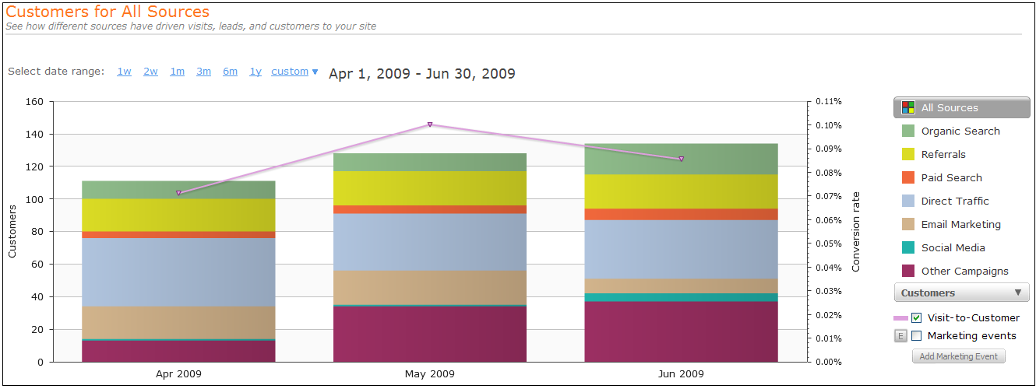

Set Traffic, Lead generation and Customer Acquisition Goals

Next, download and use the inbound marketing calculator. The calculator determines your traffic, lead and customer acquisition goals based on your monthly new revenue targets. You’ll plug in your revenue goals and your current stats (from the previous page) into the calculator. The calculator will tell you how much traffic and how many leads you need to generate in order to hit your revenue goals. It’ll also help you evaluate which inbound marketing activities to implement first by letting you vary your lead to customer and visit to customer conversion rates to determine your traffic and lead requirements. For example, if you improve visit to lead conversion rates, you’ll need less traffic to hit your revenue targets: Therefore, it would make the most sense to create more offers, build landing pages and prominently place calls to action on your website in order to convert more visitors to leads. With diligence, it is possible to increase your visitor to lead conversion rate to 5+%. Most websites convert traffic into leads at 1-2%.

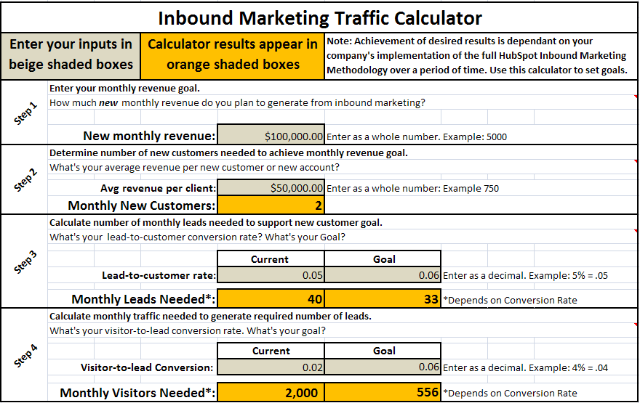
These traffic, lead and conversion targets will help you decide the appropriate amount of resources (ie time and money) to commit to inbound marketing activities. Since inbound marketing is infinitely measurable and somewhat predictable, setting goals now will also help you to measure your monthly results against your goals, allowing you to improve key metrics over time.

Define Your Ideal Lead or Customer

Define the criterion that helps you determine an ideal lead from a so-so or bad one. If you market and sell to other businesses, describe the type of company. If you market and sell to consumers, define criteria that describe the individual. You may have multiple client profiles that are ideal. If you do not know what these criteria are, you should take educated guesses. Over time, you will be able to refine your profile based on data.

Example Descriptors | Option 1 | Option 2 | Option 3 | Option 4 | Option 5
Industry
Sells to?
Number of employees
Location
Years in business
Job Title
Other:
Other:
Other:
Other:

Here’s an example of what your ideal lead profile might be after you’ve completed the table. This is data that HubSpot collects to qualify a lead.

Example Descriptors | Option 1 | Option 2 | Option 3 | Option 4 | Option 5
Industry | Technology | Manufacturing | Professional Services | Consumer services | Marketing services
Sells to? | Other businesses (B2B) | Consumers (B2C)
Number of employees | 1 | 2-5 | 6-10 | 11-25 | 25-100
Location | North America | South America | Europe | Asia | Africa
Years in business | < 1 | 2-5 | 6-10 | 11-20 | 21+
Job Title | Marketing | IT | CEO/Executive | President

Define Your Buyer Personas

Many companies sell to more than one individual; multiple influencers and decision makers. It’s critical to attract all of the people involved in the buying decision. For example, if you sell products or services to other businesses, there are usually influencers and decision makers that have typical roles within your client’s company like CEO, VP Sales or Customer Services Manager. If you sell to consumers, you might need to market and sell to different members of the family in different ways, such as children, spouses or even grandparents.

Buyer Personas are your ideal client profile(s). List specific details about the person who will likely make the decision to buy your product or service. Create a fictional stereotypical profile of this person - complete with name, age, gender, family, title, company role, interests, skills, goals, and attitude -- the more detailed the better. Add as many buyer personas as needed. Add as many criteria or descriptors as makes sense. You should review these profiles on a regular basis to make sure that your marketing actions are directed towards the needs and desires of these personas.

Descriptors | Enter Your Persona’s Information | HubSpot Persona Example
Buyer Persona Name: |  | Marketer Mary
Age: |  | 30-45
Gender: |  | Female
Family Information: |  | Married. Two kids.
Role in Company: |  | Marketing manager
Hobbies: |  | Reading, Tennis
Job Frustrations |  | Sales team is never happy. IT won’t help.
Other:
Other:
Other:

Competitive Benchmarking

Gather data about your competitors in order to uncover successful strategies you can emulate as well as how you can beat your competition where they’re weak. Are they are using social media? Is their blog effective? How strong is their SEO? In the first row, enter your own company’s information for comparison. Below that, enter the information for your competition.

Competitor’s Website | Website Grade | Search Rank | Pages in Google | Traffic  Rank | Inbound Links | Blog Grade | Twitter Grade | Facebook Grade

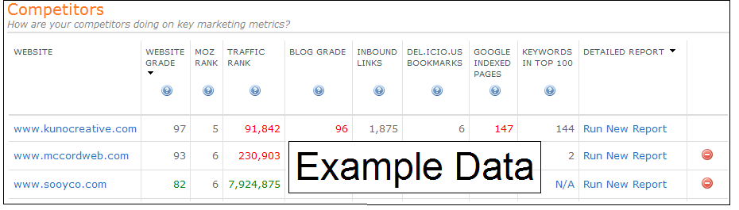
Go to HubSpot’s free www.grader.com tools and start a free HubSpot trial to quickly do a complete competitive analysis. Below is an example screenshot from Competitor Grader, available through a free HubSpot trial.

Keyword Research & Selection

Keyword phrases are words that your customers would type into a search engine such as Google or Bing to find a product or service like yours. These can be very detailed phrases that describe your service or product, or a phrase that describes a problem that your prospects might have. It’s usually better for small businesses to choose keyword phrases that include multiple words. For example, keyword phrases might contain geographical locations, such as a state or town name. You will use these keywords in a variety of ways on your site, in your blog, via social media and for your lead generation offers. Use the table below to brainstorm keywords.

View the HubSpot keyword examples below to see how the thought process works.

Inbound marketing | Inbound marketing software | Inbound marketing help | Inbound marketing training
Internet marketing | Internet marketing advice | Internet marketing webinars | Marketing webinars
SEO | Search engine optimization | Search optimization | Search engine marketing
Lead generation | Online lead generation | Website lead generation | Inbound lead generation

Once you’ve brainstormed a list of keywords, you can use Keyword Grader in a HubSpot free trial to evaluate which keywords to focus on. The ultimate goal of keyword research is to find relevant keywords that have high search volume, but low competition. You may also choose keywords if you already generate traffic or rank well for them. The trial will help you identify these keywords.

If you’re having difficulty brainstorming, you can also use the HubSpot free trial to help you identify other keywords. You can enter your competitors’ sites or a keyword, and the tool will suggest other keywords to consider.

Search Engine Optimization Checklist

Search Engine Optimization consists of 2 parts:
- On-Page SEO is done as the website is built and may be modified over time if necessary to improve search engine results. Use the checklist below for guidance as you implement your on-page SEO.
- Off-page SEO involves getting other websites to link to your website. This is done after the website is live and should be an on-going task. Follow these suggestions as you create your link building strategy.

On-Page SEO: Modifications to the pages on your website
- Review web page components to ensure that the keywords are being used in the page title, headings, anchor text, alt text and body copy.
- Make sure the title is unique on every page and is 70 characters or less.
- Make sure the meta-keywords tag focuses on the important keywords for that page. It should contain 10 keywords or less.
- Your meta-description tag should contain marketing text with keyword phrases embedded. It should be 150 characters or less.
- Add a Google xml site map.
- Add HubSpot analytics tracking code to your website for benchmarking statistics. You will review them monthly.
- Add a permanent redirect for domainname.com to www.domainname.com [This can mess up your web site if you do it wrong! So please call a techie friend for help if you are unsure how to do this step!]
- Make sure you use keywords in the link text when linking to pages within your own website.

Off-Page SEO: Links from external sources
- Make sure all of your web pages are indexed in Google
- Make sure your website is listed in free directories like DMOZ, and ZoomInfo
- Consider reputable paid directory Llistings, such as Yahoo!, Business.com or industry-specific directories
- Using HubSpot’s Link Grader, see who links to your competitors and ask them to link to your website too
- Organizational Links (.org) are considered to have greater value (i.e. chamber of commerce & other business organizations you belong to)
- Partner Links – exchange links with value-added business partners
- Social Media and Social Bookmarking Links
Website Management & Content Creation

Frequently adding new content to your website is a critical component to your Inbound Marketing Plan. More content means more opportunity to be found online and getting more pages indexed in the search engines for a wider set of keywords. Building your website using a Content Management System allows you and/or non-technical employees to easily add new content, including new web pages and a blog.

- Review your website. Are there any pages you should add? Look at your competitors' websites for ideas.
- Reference the list below to identify what pages you should add. List additional pages too.
  - About Company
  - Management Team
  - Company News
  - Careers
  - Resources
  - Customer Testimonials
  - Partners
  - Product & Services
  - Industries Served
  - Other?
  - Other?

Launching & Developing Your Business Blog

Blogging is an absolutely critical component of helping you achieve inbound marketing success. According to HubSpot data, companies that blog attract 55% more site visitors, 97% more inbound links and 434% more indexed pages. Further, companies that blog achieve 126% more lead growth than companies that don’t. Here’s a checklist of things to do when starting and planning your blogging activities.

- Subscribe to other industry blogs. Search on http://blogsearch.google.com for ideas, to subscribe and comment.
- Make sure your blog is hosted on a domain name you control. (eg http://hubspot.com/blog or http://blog.hubspot.com)
- At a minimum, post 1-3 articles per week. It’s better to write several short articles than one long article.
- Do not promote your product or service. Focus on your buyer personas and lead profiles and write about their needs and interests. Educate your readers with your blog articles to passively position yourself as the expert
- Using the HubSpot blogging platform in a trial, use blog optimizer to ensure that your keywords are used in the right spots. Using the HubSpot blogging platform in a trial, automatically promote your posts in via your social media accounts.
- List ideas for your first 3 articles and then get writing!

Blog Title/Topic | Author | Publication Date

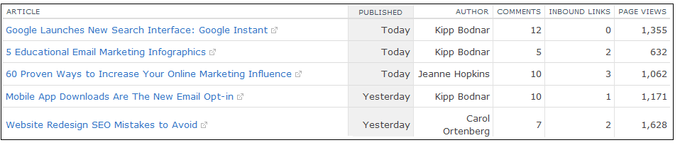
Specific types of posts such as data, infographics, how to articles and lists - usually perform very well. But, you should test to see which types of articles a) attract more comments b) attract links c) get shared via social media d) get the highest readership. If you have a blog currently, you can use a HubSpot trial to evaluate your current blog posts like the table shows.

Landing Pages & Lead Generation with Advanced Content

In addition to adding new web pages to your site and committing full force to blogging to attract more traffic to your site, you’ll also need to create advanced content in order to convert more of those visitors into leads. Examples of advanced content include webinars, presentations, podcasts, videos, whitepapers and ebooks.

Items you’ve already created can be leveraged to help you start generating leads right away. A great way to convert traffic to leads is to offer an item of value (your asset) in exchange for someone’s contact information via landing pages.

Landing pages are critical for turning a website into a lead generation tool. What will you offer to entice people to hand over their contact information? Brainstorm and list your ideas here, as well as any advanced content assets you’ve already created:

Customer Pain | Offer Title | Type of Offer | Completion Date
HubSpot Example: Sales & Marketing Don’t Get Along | How to Improve Your Sales & Marketing Alignment | Webinar

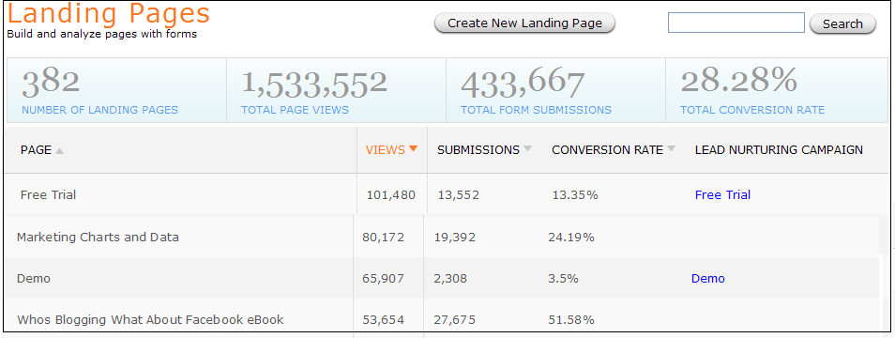
Pay-Per-Click ads, newsletters, web pages and blogs can all direct traffic to a landing page. You should have a different landing page for each offer, in order to measure its effectiveness. See the screen shot below for an example of how different HubSpot offers perform. HubSpot data shows that educational and non-promotional offers perform better. HubSpot customer data also shows that customers with more landing pages produce more leads and convert a higher percentage of visitors into leads. You can use a HubSpot trial to build and launch landing pages.
Setting up Social Media Accounts & Building a Following

Your intial focus when getting involved with social media should be to build relationships, have conversations, and establish connections. Once you have a following, you can share links to your own content via your social media accounts, in order to drive traffic to your website.

Twitter - Go to www.twitter.com, create a username and a very brief profile. Now you are ready to tweet! A few things to note:
- Tweets are limited to 140 characters and should be meaningful and interesting to your buyer personas.
- Follow others whose tweets are useful and informative, retweet these to your followers and respond to these comments too.
- Use free Twitter clients (such as Tweetdeck) to organize who you are following into more meaningful groups.
LinkedIn - Go to www.linkedin.com and create an account. Complete your profile – aim for 100% completion! The more info you give, the more likely you’ll be found by others. Things you can do in LinkedIn to help build business relationships and promote your company are:
- Invite Friends / Trusted Colleagues into your network
- Join Groups (you can join up to 50) – Ask / Answer Questions to show your knowledge
- Request/write recommendations (remember social media is give and take!)

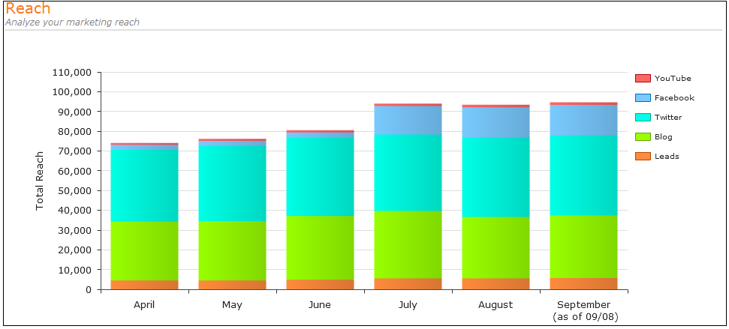
Facebook - Go to www.facebook.com and create an account. You need to create a personal profile first and then you can add a business page. As with LinkedIn, the more complete your profile is, the more likely you’ll be found by others. Facebook tends to be a little more relaxed and personal than LinkedIn, but you can still connect with colleagues, join common interest groups, engage in discussions & build relationships.
Once you’ve set up your accounts, you can enter your accounts into your HubSpot trial in order to begin tracking your reach.

Social Media Monitoring

Once you have your social media accounts setup, you should start monitoring important keywords like your brand and product names, as well as keywords you’ve identified through your keyword research process. It is important to monitor keywords across social media platforms including Twitter, Facebook and Linkedin. However, other social media sharing platforms are important too, including Yahoo Answers, Youtube, and of course, the blogosphere. Because of the number of sites and number of keywords that you should monitor, you should use software to help you. You can use a HubSpot free trial to identify which words to monitor and begin interacting with the people who mention them. This interaction should lead to traffic, leads and sales if done right. Enter the 10 most important keywords to track for your business.

See the image to the right of how the HubSpot social media monitoring tool detects content containing keywords that are important to HubSpot like “lead generation” and “inbound marketing”.
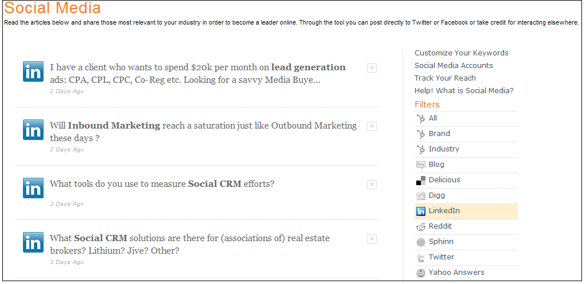
Social Media Schedule

Just like blogging, you should work social media into your daily schedule. Add it to your calendar and treat it like a meeting that you absolutely cannot miss! In the beginning, it may help you to create a weekly schedule using the table below so that you can plan ahead.

 | Monday | Tuesday | Wednesday | Thursday | Friday
Blog
Twitter
LinkedIn
Facebook

In social media, it’s key to Do Something Every Day!
- When you create a new blog post, tweet about it!
- Comment on someone else’s blog
- When you attend a live networking event, follow up with someone you met by connecting with them on LinkedIn or Facebook.
- Read any interesting blog articles? See a good video on YouTube? Tweet about it. Share it on LinkedIn or Facebook.
- Make recommendations on LinkedIn.
- Post a question or answer one
Email Marketing & Lead Nurturing

- Build Email List – smaller, targeted lists is preferred over a large list of people who don’t want your newsletter
- Leverage a HubSpot trial to send simple email campaigns to your opt-in list.
- Use HubSpot’s integrated landing pages and email marketing database to email your new leads.
- Use HubSpot’s lead segmentation to segment your leads according to the criterion you defined earlier.
- Use HubSpot’s lead nurturing to automatically send a sequence of emails to send to new leads.
- Keep emails or newsletters concise – with links to larger bodies of content on your website or blog. Ideally, promote new offers and landing pages to get your email subscribers to raise their hand and opt-in to your sales process.
- Create valuable newsletter content keeping in mind your business goals and your buyer personas
- Create calls to action in your emails that drive traffic to your landing pages.
- Make sure the “From” name is one your audience will recognize
- Use attention getting subject lines
- Test, test, test. Measure click through rates to determine how effective your content and offers are. Track your campaigns ability to drive signs ups via HubSpot Sources and built in email marketing tracking codes. If you’re using a 3rd party email marketing tool, create tracking codes first and embed them in your emails.

Use this template to outline your first email campaigns and lead nurturing messages.

From: _______________________________ Frequency: _________________(weekly, monthly)
Subject: _______________________________ Send on: _________________ (day of week)

Topic | Call to Action | Link to
1.
2.
3.

Pay-Per-Click Advertising

Organic ranking is greatly preferred over pay-per-click advertising for a couple of reasons. One being that organic ranking is free. Two is that statistics show that people are more likely to click on organic links than advertisements. PPC advertising does have its merits in some cases, such as a recent product launch where you need to get found immediately and don’t have the time to wait for organic results. PPC ads can also be a great way to test out your keywords before implementing search engine optimization for them; you can figure out which keyword phrases perform better using PPC and then use those phrases in your organic SEO strategy.

When planning ppc and online advertising campaigns, you should group keywords into campaigns and make sure that your landing pages match your ads and keywords. In other words, ads should include the keywords the user enters into the search engine. Your landing pages should include these words too. Use the table below to start planning campaigns for the offers you’ve created.

Ad Campaign/Group | Keyword | Offer/Landing Page

Be sure to have good analytics in place, so you can calculate the ROI on each ad campaign and keyword. Over time, you should invest more in campaigns that produce qualified leads and customers and cut budgets for keywords and ads that don’t produce an ROI. View the data below for a specific campaign with a set of keywords that performed well for HubSpot.
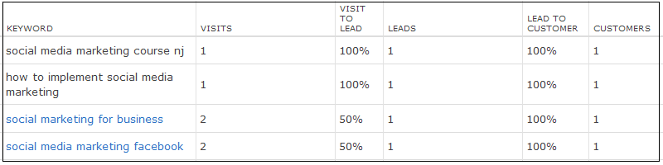

Measurement & Analysis for Continuous Improvement

There are many statistics that you can measure over time to determine how successful your Inbound Marketing Strategy is, and how to improve your results. You should be checking your analytics at least monthly and much more frequently when you are tweaking and improving ongoing activities or campaigns.

Probably the most valuable measure of success is your conversion rates. Your conversion rates indicate the number of visitors to your website that became leads and the number of leads that became customers. You should measure conversion rates and overall numbers from each traffic source incuding SEO, blogging, social media, ppc and email marketing. Then, you should evaluate which activities to continue, tweak or stop based on what’s working and what’s not, as well as what can most easily be improved. Once your HubSpot trial is fully setup, HubSpot Sources automatically measures and reports this data.

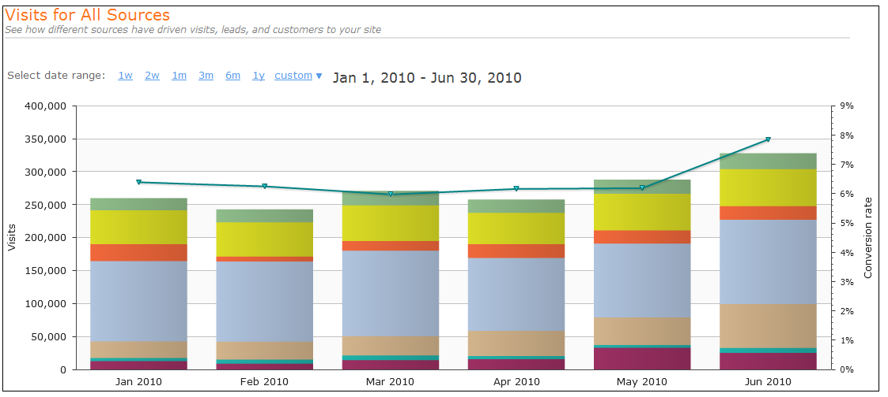

Skills Required for Inbound Marketing Success

Inbound marketing requires skills that you or your organization may or may not possess. Your organization may also need to develop new skills. You may be able to achieve your sales and marketing objectives more effectively by outsourcing certain tasks, hiring an inbound marketing agency to do inbound marketing for you, or hiring a coach or consultant to guide you as you do the work.

For each of the skills listed below, list the person/people in your organization who has these skills. If no one in your organization has these skills, you should write that.

Skills | Primary Resource | Resource 2 | Resource 3
Writing/Blogging
Analytical Skills/Data interpretation
Design & Layout
Messaging/Branding

Resources Required for Inbound Marketing Success

It should be obvious by now that implementing a successful inbound marketing strategy requires an investment of time and money. Given your skills and goals, you’ll need to estimate how much time you should spend on each activity, initially and ongoing. You may choose to delay or skip specific activities based on your goals and budget. Consult an experienced inbound marketer to discuss how to balance your goals with your budget and time. You may find that your goals are too aggressive given your time, or that you might need to outsource more of your work in order to achieve your objectives.

Activity | Initial Setup Time | Monthly Time | Outsourced Time
Goal Setting
Tracking Results vs Goals
Keyword Research
On Page SEO
Off Page SEO
Website Content Creation
Business Blogging
Social Media
Advanced Content/Lead Generation
Email marketing/Lead Nurturing
PPC

Software Required for Inbound Marketing Success

In order to effectively do inbound marketing, software is necessary. There are a variety of solutions for each of the capabilities listed below. An integrated toolset that provides all of the capabilities below will enable you to most effectively and efficiently execute your inbound marketing strategy.
Software/System | Yes – Inadequate - No | Current Tool
Attracting More Traffic | Yes – Inadequate - No
SEO Keyword Research | Yes – Inadequate – No
SEO Link Analysis | Yes – Inadequate – No
SEO Page Analysis | Yes – Inadequate – No
Blogging Software | Yes – Inadequate – No
Social Media Monitoring | Yes – Inadequate – No
Content Management System | Yes – Inadequate – No
Converting Traffic into Leads & Customers | Yes – Inadequate - No
Landing Page Builder | Yes – Inadequate – No
Lead Management Database | Yes – Inadequate – No
Email Lead Nurturing | Yes – Inadequate – No
Prospect Identification | Yes – Inadequate – No
Lead Intelligence/Tracking | Yes – Inadequate – No
Lead Segmentation | Yes – Inadequate – No
Email Marketing | Yes – Inadequate – No
Analysis for Continuous Improvement | Yes – Inadequate - No
Closed Loop Marketing/Website Analytics | Yes – Inadequate – No
Customer Relationship Management System | Yes – Inadequate – No
Blog Analytics | Yes – Inadequate – No
Reach Analytics | Yes – Inadequate – No
Competitive Analytics | Yes – Inadequate – No
Integration Points | Yes – Inadequate – No
Keyword Research and Web Analytics | Yes – Inadequate - No
On Page SEO & Content Management System | Yes – Inadequate – No
Keyword Research and Blogging Platform | Yes – Inadequate – No
Social Media & Blogging | Yes – Inadequate – No
Social Media & Lead Database | Yes – Inadequate - No
CRM Integration with Landing Pages | Yes – Inadequate – No
Landing Pages and Web Analytics | Yes – Inadequate – No
CRM Integration with Web Analytics | Yes – Inadequate – No
List Creation & Landing Pages | Yes – Inadequate – No

About HubSpot:

HubSpot provides inbound marketing software and training that helps small and mid-sized businesses:

- Attract more traffic to their site via SEO, blogging and social media
- Convert more visitors into leads via landing pages
- Convert leads into customers via email marketing, lead nurturing, lead intelligence and crm integration and
- Analyze and continuously improve results via lead tracking and website, blog, social media and closed loop marketing analytics

While this workbook provides a roadmap to help you plan your inbound marketing strategy, you’ll need tools and additional training and processes in order to implement it effectively. Fully leveraging a HubSpot free trial will help you see this firsthand.

Seek out assistance from a HubSpot Certified Reseller or HubSpot Inbound Marketing Specialist to help you complete this worksheet and start your plan towards inbound marketing success.

Based in Cambridge, MA, HubSpot is a 160 person company with more than 3,000 customers. Learn more HubSpot.com

