**Risk Assessment Form Template**

| **Risk Description** |
| --- |
| **If a staff member trips on a wet floor, they may injure themselves and subsequently sue the company.** |

| **Risk Type** | |
| --- | --- |
| Financial | Y |
| Operational |  |
| Reputational |  |
| Human Safety | **Y** |
| Other |  |

| **Source of Risk** |
| --- |
| **Open drink containers and leaking air conditioning units.** |

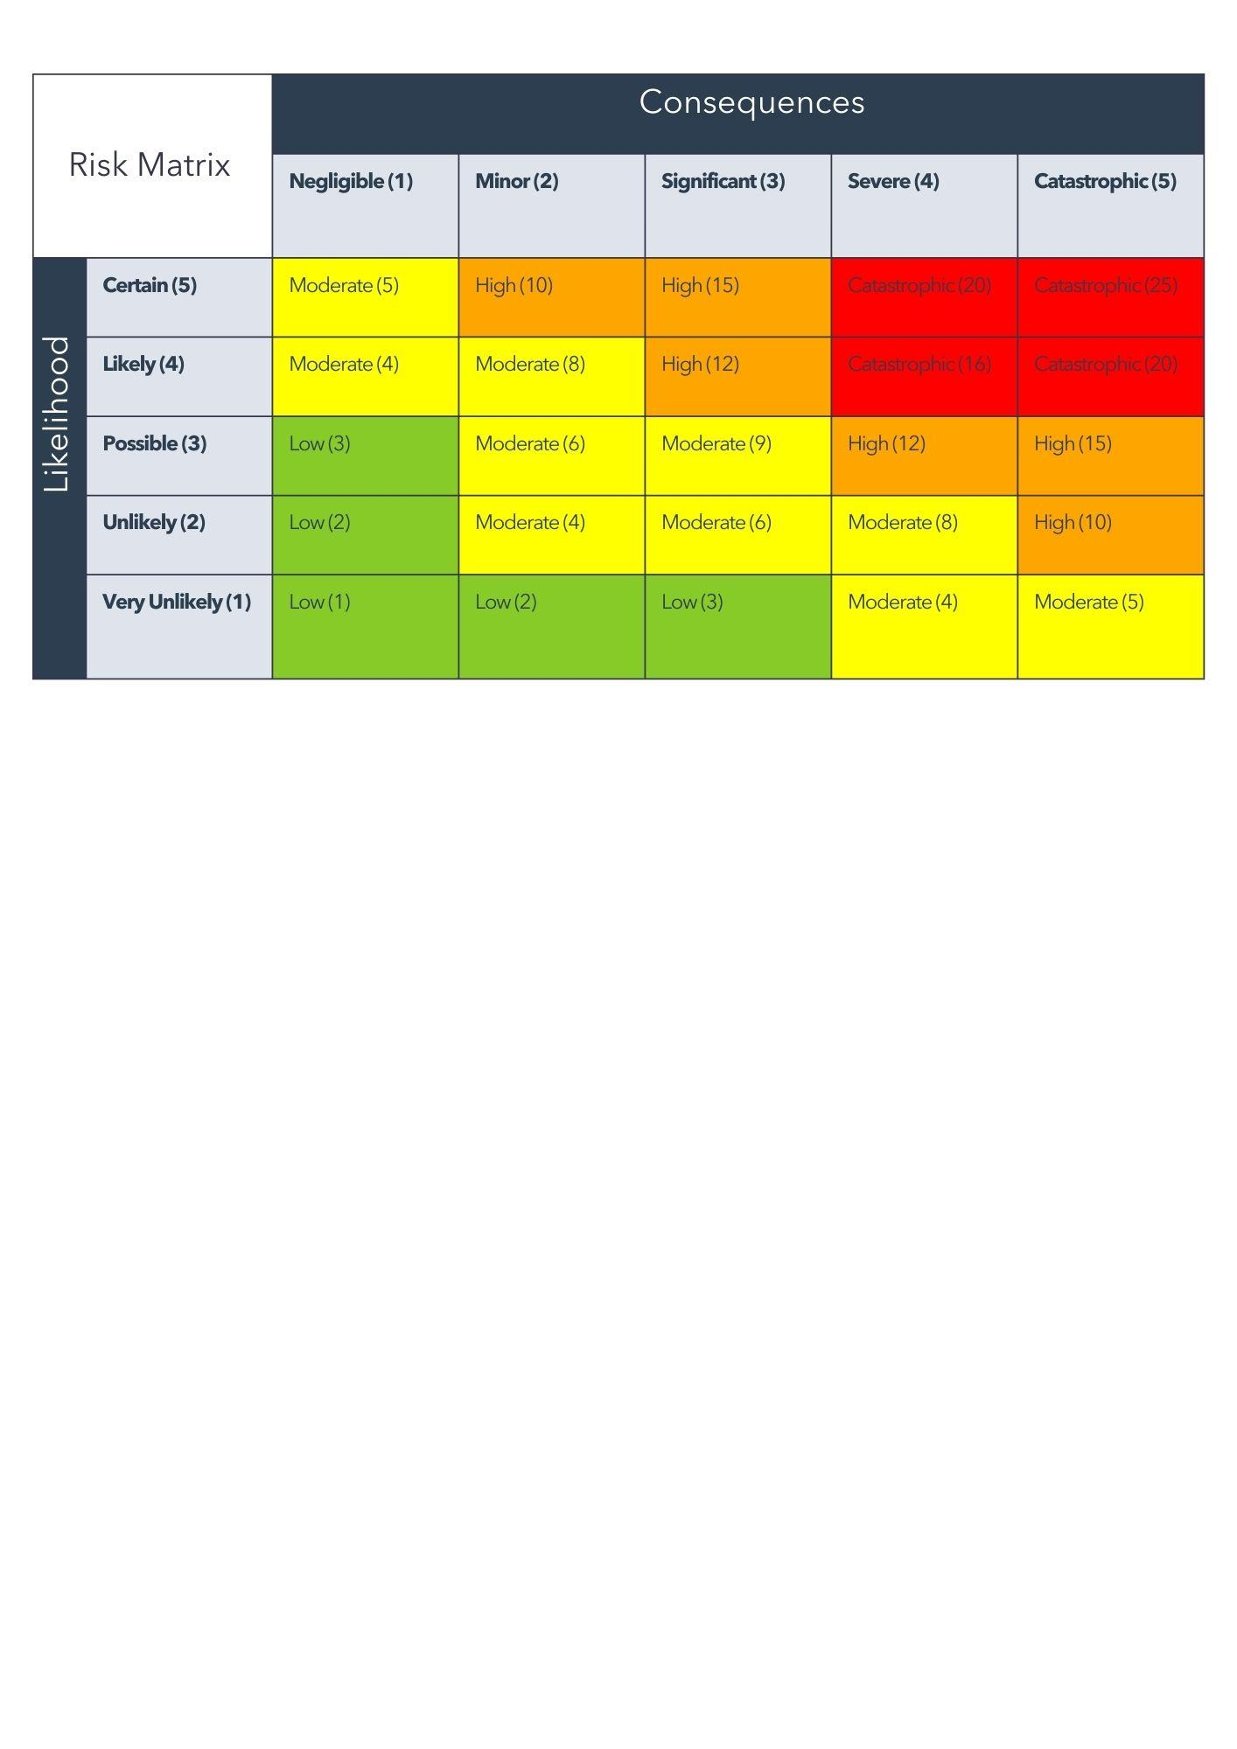

| Risk Severity Level | **High** |
| --- | --- |

| **Actions to Mitigate Risk** | | | |
| --- | --- | --- | --- |
| **Action** | **Risk Addressed** | **Person Responsible** | **Due Date** |
| **Check floors every hour** | **Yes** | **Cleaner** | **08/30** |
| **Email staff and ask them not to walk around with open containers** | **Yes** | **Office Manager** | **08/30** |
| **Repair leaking air conditioning units** | **Yes** | **Maintenance staff** | **08/30** |
|  |  |  |  |

| **Date Reviewed** | **Approving Official** | **Signature** |
| --- | --- | --- |
| **08/30** | **J. Doe, CEO** |  |

| **Comments** |
| --- |
| **The level of compliance has been high, but the risk requires constant monitoring.** |